SPRINT 0 — PROJECT INITIATION & ARCHITECTURE
SPRINT GOAL:
Understand the pharmaceutical business ecosystem, define business and technical requirements, identify data sources, and establish the foundation and architecture for the Enterprise Pharmaceutical Data Platform.
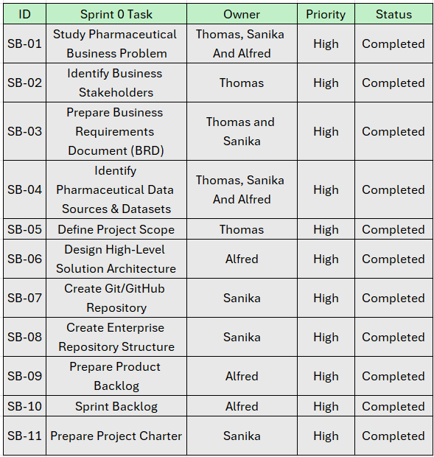

SPRINT 1 — DATA INGESTION & STAGING
SPRINT GOAL:
To analyse the selected pharmaceutical data sources, prepare the Source Inventory and Data Dictionary, develop Pentaho ingestion pipelines for heterogeneous data formats, and load raw data into PostgreSQL staging with logging and exception handling.
